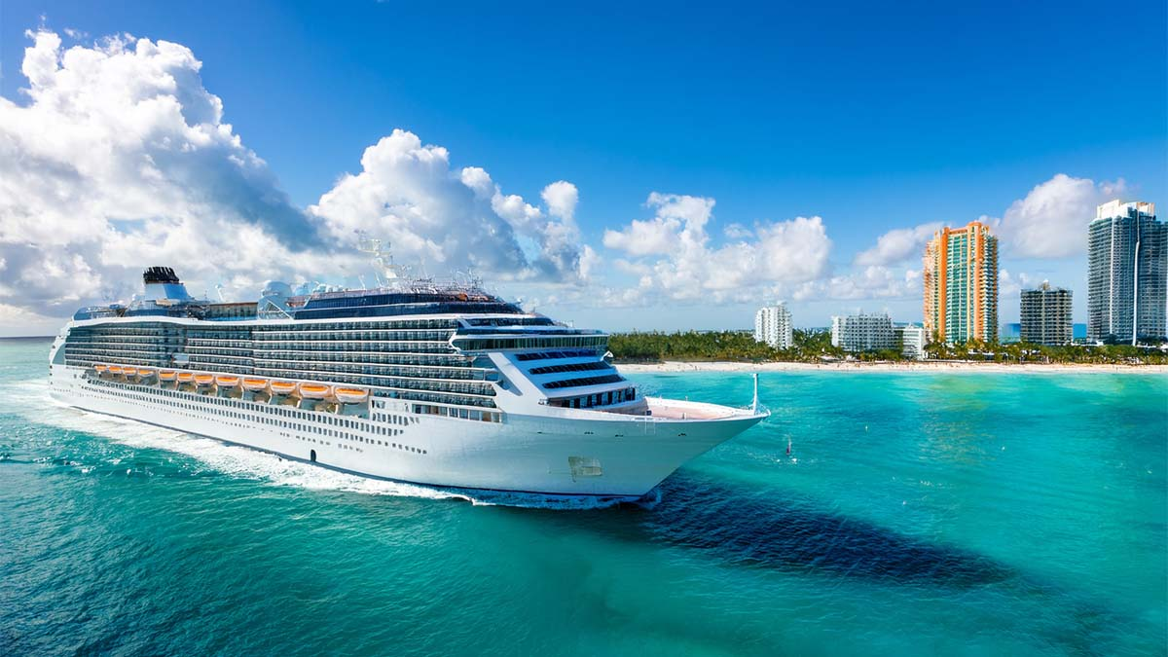
Cruise Packing Checklist
Clothing |  | Accessories |  | Electronics
Toiletries |  | Medications |  | Miscellaneous
source: www.neworchards.com
