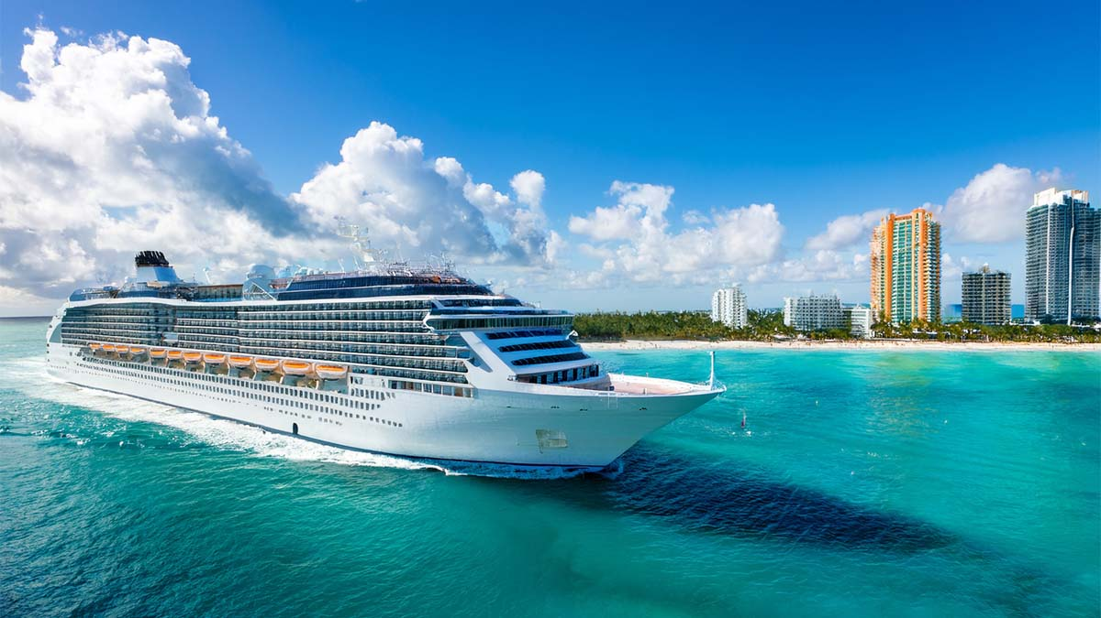
Cruise Vacation Packing List
Clothing |  |  | Accessories |  |  | Electronics
☐ |  |  | ☐ |  |  | ☐
☐ |  |  | ☐ |  |  | ☐
☐ |  |  | ☐ |  |  | ☐
☐ |  |  | ☐ |  |  | ☐
☐ |  |  | ☐ |  |  | ☐
☐ |  |  | ☐ |  |  | ☐
☐ |  |  | ☐ |  |  | ☐
☐ |  |  | ☐ |  |  | ☐
☐ |  |  | ☐ |  |  | ☐
☐ |  |  | ☐ |  |  | ☐
☐ |  |  | ☐ |  |  | ☐
Toiletries |  |  | Medications |  |  | Miscellaneous
☐ |  |  | ☐ |  |  | ☐
☐ |  |  | ☐ |  |  | ☐
☐ |  |  | ☐ |  |  | ☐
☐ |  |  | ☐ |  |  | ☐
☐ |  |  | ☐ |  |  | ☐
☐ |  |  | ☐ |  |  | ☐
☐ |  |  | ☐ |  |  | ☐
☐ |  |  | ☐ |  |  | ☐
☐ |  |  | ☐ |  |  | ☐
☐ |  |  | ☐ |  |  | ☐
☐ |  |  | ☐ |  |  | ☐
source: www.neworchards.com
